UNITED STATES
SECURITIES AND EXCHANGE COMMISSION
Washington, D.C. 20549
SCHEDULE 14A INFORMATION
Proxy Statement Pursuant to Section 14(a) of the
Securities Exchange Act of 1934
(Amendment No. ^ )
Filed by the Registrant ☒ Filed by a Party other than the Registrant ☐
Check the appropriate box:

☐ | Preliminary Proxy Statement

☐ | Confidential, for Use of the Commission Only (as permitted by Rule 14a-6(e)(2))

☐ | Definitive Proxy Statement

☒ | Definitive Additional Materials

☐ | Soliciting Material under §240.14a-12
HURON CONSULTING GROUP INC.
(Name of registrant as specified in its charter)
^
(Name of person(s) filing proxy statement, if other than the registrant)
Payment of Filing Fee (Check the appropriate box):

☒ | No fee required.

☐ | Fee computed on table below per Exchange Act Rules 14a-6(i)(1) and 0-11.

 | (1) | Title of each class of securities to which the transaction applies:
^

 | (2) | Aggregate number of securities to which the transaction applies:
^

 | (3) | Per unit price or other underlying value of the transaction computed pursuant to Exchange Act Rule 0-11 (set forth the amount on which the filing fee is calculated and state how it was determined):
^

 | (4) | Proposed maximum aggregate value of the transaction:
^

 | (5) |  | Total fee paid:
^

☐ | Fee paid previously with preliminary materials.

☐ | Check box if any part of the fee is offset as provided by Exchange Act Rule 0-11(a)(2) and identify the filing for which the offsetting fee was paid previously. Identify the previous filing by registration statement number, or the Form or Schedule and the date of its filing.

 | (1) | Amount Previously Paid:
^

 | (2) | Form, Schedule or Registration Statement No.:
^

 | (3) | Filing Party:
^

 | (4) | Date Filed:
^


You invested in HURON CONSULTING GROUP INC. and its time to vote!
You have the right to vote on proposals being presented at the Annual Meeting. This is an important notice regarding the availability of proxy material for the stockholder meeting to be held on May 7, 2021.
Get informed before you vote
View the Annual Report and Notice and Proxy Statement online OR you can receive a free paper or email copy of the material(s) by requesting prior to April 23, 2021. If you would like to request a copy of the material(s) for this and/or future stockholder meetings, you may (1) visit www.ProxyVote.com, (2) call 1-800-579-1639 or (3) send an email to sendmaterial@proxyvote.com. If sending an email, please include your control number (indicated below) in the subject line. Unless requested, you will not otherwise receive a paper or email copy.

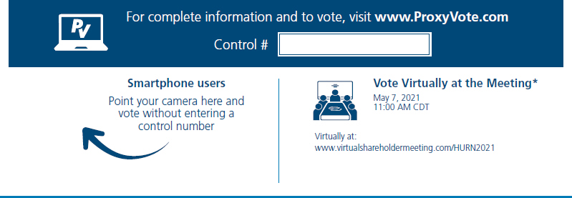
*Many stockholder meetings have attendance requirements including, but not limited to, the possession of an attendance ticket issued by the entity holding the meeting. Please check the meeting materials for any special requirements for meeting attendance.
V1

Vote at www.ProxyVote.com

THIS IS NOT A VOTABLE BALLOT
This is an overview of the proposals being presented at the
upcoming stockholder meeting. Please follow the instructions on
the reverse side to vote these important matters.

Voting Items |  |  |  | Board  Recommends
1. |  | Election of Directors*
 |  | Nominees: |  | For
 |  | 01) Hugh E. Sawyer
 |  | 02) Debra L. Zumwalt
2. |  | To approve an amendment to the Companys Amended and Restated 2012 Omnibus Incentive Plan. |  | For
3. |  | An advisory vote to approve the Companys executive compensation. |  | For
4. |  | To ratify the appointment of PricewaterhouseCoopers LLP as the Companys independent registered public accounting firm for the fiscal year ending December 31, 2021. |  | For
NOTE: Such other business as may properly come before the meeting or any adjournment thereof. *Nominated by the Board of Directors to serve as Class II Directors.

D36744-P49950

