UNITED STATES

SECURITIES AND EXCHANGE COMMISSION
Washington, D.C. 20549

SCHEDULE 14A

Proxy Statement Pursuant to Section 14(a) of the
Securities Exchange Act of 1934
(Amendment No. )

Filed by the Registrant ☒

Filed by a Party other than the Registrant ☐

Check the appropriate box:

- Preliminary Proxy Statement

- Confidential, for Use of the Commission Only (as permitted by Rule 14a-6(e)(2))

- Definitive Proxy Statement

- Definitive Additional Materials

- Soliciting Material under §240.14a-12

HURON CONSULTING GROUP INC.

(Name of Registrant as Specified In Its Charter)

(Name of Person(s) Filing Proxy Statement, if other than the Registrant)

Payment of Filing Fee (Check all boxes that apply):

- No fee required

- Fee paid previously with preliminary materials

- Fee computed on table in exhibit required by Item 25(b) per Exchange Act Rules 14a-6(i)(1) and 0-11


Your Vote Counts!

HURON CONSULTING GROUP INC.

2022 Annual Meeting

Vote by May 05, 2022

11:59 PM ET



HURON CONSULTING GROUP INC.
550 W. VAN BUREN STREET, 17th FLOOR

CHICAGO, IL 60607


You invested in HURON CONSULTING GROUP INC. and it’s time to vote!

You have the right to vote on proposals being presented at the Annual Meeting. This is an important notice regarding the availability of proxy material for the stockholder meeting to be held on May 06, 2022.

Get informed before you vote

View the Annual Report, Notice & Proxy Statement online OR you can receive a free paper or email copy of the material(s) by requesting prior to April 22, 2022. If you would like to request a copy of the material(s) for this and/or future stockholder meetings, you may (1) visit www.ProxyVote.com, (2) call 1-800-579-1639 or (3) send an email to sendmaterial@proxyvote.com. If sending an email, please include your control number (indicated below) in the subject line. Unless requested, you will not otherwise receive a paper or email copy.
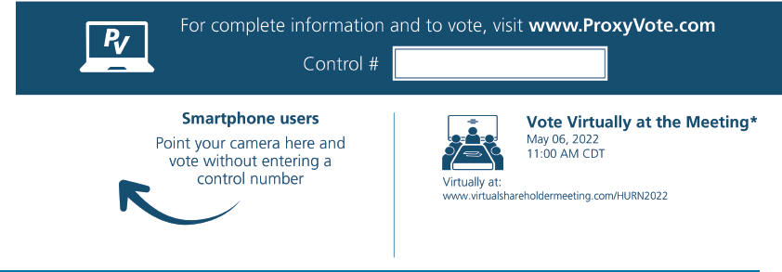

*Please check the meeting materials for any special requirements for meeting attendance.

Vote at www.ProxyVote.com

THIS IS NOT A VOTABLE BALLOT

This is an overview of the proposals being presented at the

upcoming stockholder meeting. Please follow the instructions on

the reverse side to vote these important matters.

Voting Items


Board

Recommends

- To elect to the board of directors the three persons nominated by the board of directors to serve as Class III Directors.

 | Nominees: |  |  | For
 | 01. John McCartney | 02. Ekta Singh-Bushell | 03. Peter K. Markell
2. | An advisory vote to approve the Company’s executive compensation. |  |  | For
3. | To ratify the appointment of PricewaterhouseCoopers LLP as the Company’s independent registered public accounting firm for |  |  | For
 | the fiscal year ending December 31, 2022. |  |  | For
NOTE: To transact such other business as may properly come before the meeting or any postponement or adjournment thereof.

Prefer to receive an email instead? While voting on www.ProxyVote.com, be sure to click “Sign up for E-delivery”.

